
COMSATS University Islamabad
Department of Computer Science

CSC270 – Database Systems
Lab 5

Submitted By: Muhammad Abdullah
Reg No: FA24-BSE-042

GRADED TASKS

Task 1:
Q. Write a SQL statement that displays the highest, lowest, sum, and average salary of all employees. Label the columns as Maximum, Minimum, Sum, and Average, respectively. Round your results to the nearest whole number.

Statement:
SELECT
ROUND(MAX(salary)) AS Maximum,
ROUND(MIN(salary)) AS Minimum,
ROUND(SUM(salary)) AS Sum,
ROUND(AVG(salary)) AS Average
FROM
employees;

Output:
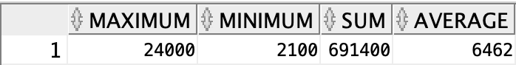

Task 2:
Q. Write a SQL statement to display the number of people with the same job.

Statement:
SELECT
job_id,
COUNT(*) AS number_of_employees
FROM
employees
GROUP BY
job_id;

Output:
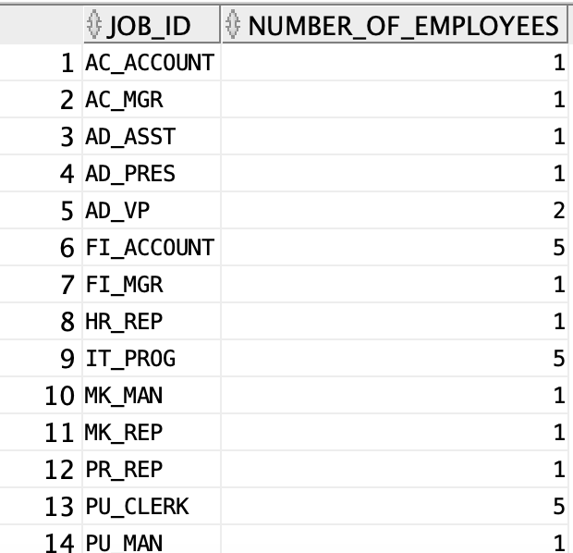

Task 3:
Q. Write a SQL statement to determine the number of managers without listing them. Label the column as Number of Managers.

Statement:
SELECT
COUNT(DISTINCT manager_id) AS "Number of Managers"
FROM
employees
WHERE
manager_id IS NOT NULL;
Output:

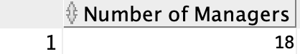

Task 4:
Q. Write a SQL statement that finds the difference between the highest and lowest salaries. Label the column DIFFERENCE.

Statement:
SELECT
MAX(salary) - MIN(salary) AS DIFFERENCE
FROM
Employees
Output:

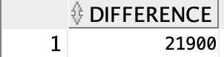

Task 5:
Q. Write a SQL statement that displays the manager number and the salary of the lowest-paid employee for that manager. Exclude anyone whose manager is not known. Exclude any groups where the minimum salary is $6,000 or less. Sort the output in descending order of salary.
Statement:
SELECT
manager_id,
MIN(salary) AS lowest_salary
FROM
employees
WHERE
manager_id IS NOT NULL
GROUP BY
manager_id
HAVING
MIN(salary) > 6000
ORDER BY
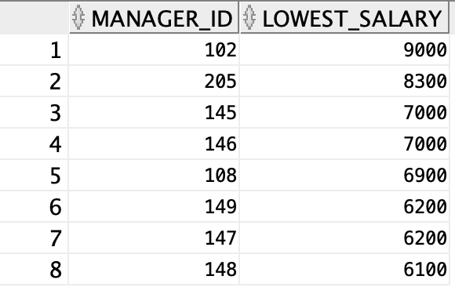
MIN(salary) DESC
Output:

Task 6:
Write a SQL statement that displays the job, the salary for that job based on department number, and the total salary for that job, for departments 20, 50, 80, and 90, giving each column an appropriate heading.
Statement:
SELECT
job_id,
salary,
department_id,
SUM(salary) AS "Total Salary"
FROM
employees
WHERE
department_id IN (20, 50, 80, 90)
GROUP BY
job_id, salary, department_id;
Output:
